

**课程设计报告**

**课 程 名 称： Object oriented python**

**课程设计名称： Snake game**

**系部名称：International Education Center**

**学生姓名：Arafat Hoshen**

**班 级：class 3**

**学 号： 201826030310**

**成 绩：**

**指导教师：籍想爸爸**

**开课时间：2019-2020学年第2学期**

### **Index**

**1.Introduction** **1**

**2.Project ideas 2**

**3.project description 3**

**4.Source code 4**

**5.Acknowledge** **5**

### **1.Introduction**

[**Snake**](http://www.grantjenks.com/docs/freegames/snake.html)**– classic arcade game. Use the arrow keys to navigate and eat the green food. Each time the food is consumed, the snake grows one segment longer. Avoid eating yourself or going out of bounds!**

**Python is a high-level, interpreted and general-purpose dynamic programming language that focuses on code readability. The syntax in Python helps the programmers to do coding in fewer steps as compared to Java or C++. The Python is widely used in bigger organizations because of its multiple programming paradigms. They usually involve imperative and object-oriented functional programming. It has a comprehensive and large standard library that has automatic memory management and dynamic features.**

**Our project is to implement the** [**Snake**](http://www.grantjenks.com/docs/freegames/snake.html)**– game which will features like single player and two player modes. In single player mode we have used game theory logics like minimax algorithms to determine the best move that the computer plays.**

**The project was tested and it turned out to be 72.33% accurate.**

### **2.Project ideas**

**First of all we need to implement the best move logic for the computer to play in single player mode. As already stated we have used minimax algorithms to determine the best move.**

### **3.project description**

**As we all know about** [**Snake**](http://www.grantjenks.com/docs/freegames/snake.html)**– game is a very famous game for many years. In past years, it can only be played with pen and paper by using cross and zero. Nowadays, as our technology is enhancing it has changed its place from paper to technical gadgets. In this python project, we are going to develop an interactive game where two players will be able to play against each other in python terminal or suitable GUI by using a keyboard and mouse in their PCs.**

### 

### **4.Source code**

### **#How I make this game short interface**

1. **Installing Pygame.**
2. **Create the Screen.**
3. **Create the Snake.**
4. **Moving the Snake.**
5. **Game Over when Snake hits the boundaries.**
6. **Adding the Food.**
7. **Increasing the Length of the Snake.**
8. **Displaying the Score.**

**This code is without using GUI (Graphical user interface)**

from turtle import *  
from random import randrange  
from freegames import square, vector  
  
food = vector(0, 0)  
snake = [vector(10, 0)]  
aim = vector(0, -10)  
  
def change(x, y):  
 *"Change snake direction."* aim.x = x  
 aim.y = y  
  
def inside(head):  
 *"Return True if head inside boundaries."* return -200 < head.x < 190 and -200 < head.y < 190  
  
def move():  
 *"Move snake forward one segment."* head = snake[-1].copy()  
 head.move(aim)  
  
 if not inside(head) or head in snake:  
 square(head.x, head.y, 9, 'red')  
 update()  
 return  
  
 snake.append(head)  
  
 if head == food:  
 print('Snake:', len(snake))  
 food.x = randrange(-15, 15) * 10  
 food.y = randrange(-15, 15) * 10  
 else:  
 snake.pop(0)  
  
 clear()

for body in snake:  
 square(body.x, body.y, 9, 'black')  
  
 square(food.x, food.y, 9, 'green')  
 update()  
 ontimer(move, 100)  
  
setup(420, 420, 370, 0)  
hideturtle()  
tracer(False)  
listen()  
onkey(lambda: change(10, 0), 'Right')  
onkey(lambda: change(-10, 0), 'Left')  
onkey(lambda: change(0, 10), 'Up')  
onkey(lambda: change(0, -10), 'Down')  
move()  
done()

**After Run This program**

**This is my computer interface**

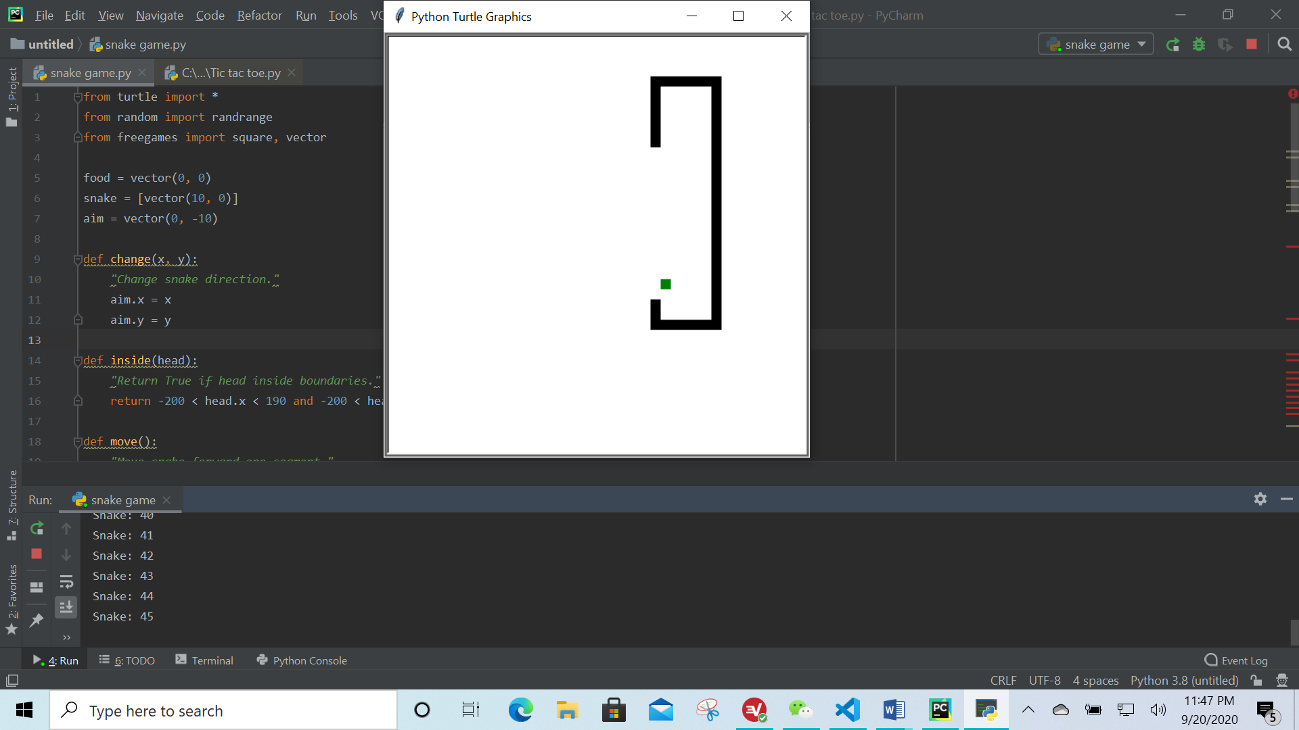

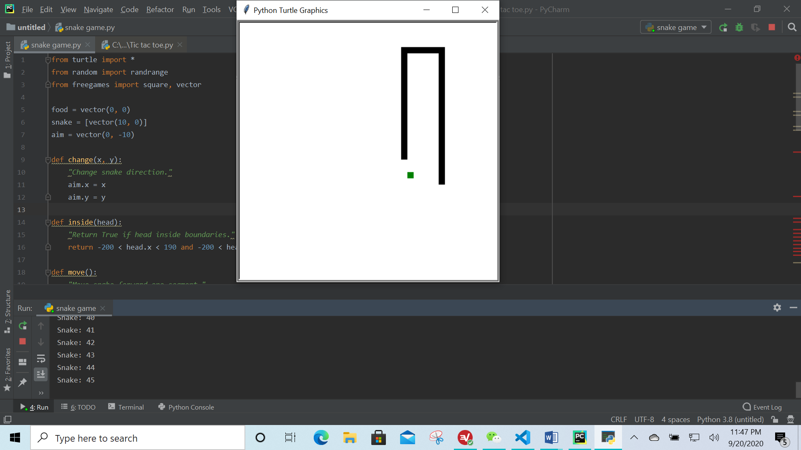

### **5.Acknowledge**

I would like to express my special thanks of gratitude to my teacher 籍想爸爸laoshi as well as our principal 籍想爸爸 who gave me the golden opportunity to do this wonderful project on the topic making games by using Python.which also helped me in doing a lot of Research and i came to know about so many new things I am really thankful to them.

Secondly i would also like to thank my parents and friends who helped me a lot in finalizing this project within the limited time frame.

*** laoshi my request you play my game on your computer ***